

**Project Status Report**

**Project Name: APC Student Assistant System**

**Department: Bachelor of Science and Computing and Information Technology**

**Focus Area:** **Student Assistant Students**

**Product/Process:** **In progress of updating all general information of our system**

**Prepared By:**

|  |  |
| --- | --- |
| **Document Owner(s)** | **Project/Organization Role** |
| Abrera, Jenna Ann B. | Project Documenter/Designer |
| Cruz, Lorenz Matthew M. | Project Developer |
| Romero, Jun Kimuel C. | Project Manager/Web Developer |
| Tomas, Gener Joseph G. | Project Analyst/Developer |

**Project Status Report Version Control**

|  |  |  |  |
| --- | --- | --- | --- |
| **Version** | **Date** | **Author** | **Change Description** |
| 3.0 | 10/18/16 | Romero, Jun Kimuel | Document created |
| 3.6  3.7  3.8  3.9 | 10/18/16  10/18/16  10/18/16  10/18/16 | Abrera, Jenna Ann  Cruz, Lorenz Matthew  Romero, Jun Kimuel  Tomas, Gener Joseph | * We’re fixing bugs in our system and doing a brainstorming to provide the desire output of our system. * We’re fixing bugs in our system and doing a brainstorming to provide the desire output of our system. * We’re fixing bugs in our system and doing a brainstorming to provide the desire output of our system. * We’re fixing bugs in our system and doing a brainstorming to provide the desire output of our system. |

**TABLE OF CONTENTS**

1 PROJECT STATUS REPORT PURPOSE 3

2 PROJECT STATUS REPORT TEMPLATE 3

2.1 Project Status Report Details 3

2.2 Project Status Report Template 4

3 PROJECT STATUS REPORT APPROVALS 7

4 APPENDICES 8

4.1 Document Guidelines 8

4.2 Project Status Report Sections Omitted 8

# 

# PROJECT STATUS REPORT PURPOSE

Accomplishing the work breakdown schedule and activity list. Working on the prototype too.

# PROJECT STATUS REPORT TEMPLATE

## Project Status Report Details

* Project Description
  + Student Assistant who perform their given task for their scholar funding.
* Budget Report

O to contribute at least 50 pesos each member per week for the expenses for the project.

* Risk Management Report

O Some of the functions in cobalt language are similarly the same problem and we’re able to locate those specific problem but we can’t fix those problem. And some of those functionalities are not familiar to us.

* Issues Report

o One of the members is not able to go to the project presentation

* Project recommendations to ensure success including lessons learned.
  + We should have our own copy of our prototype to be able to present on time
  + We should be able to manage our time to study and practice cobalt

## Project Status Report Template

|  |  |  |
| --- | --- | --- |
| **APC Student Assistant System** | | |
| Prepared by:  Abrera, Cruz, Romero, and Tomas | Date:  11/18/16 | Reporting Period:  11/14/16 to 11/19/16 |
| Project Overall Status:  We are working with our prototype to finish it and present it completely for our Defense. | | |
| Project Summary:  This project will help the Disciplinary Office Head to minimize the time of checking the paper of each student and also to be able to record all the information that the student will pass for their Student Assistant task. | | |

|  |  |  |  |  |  |
| --- | --- | --- | --- | --- | --- |
| **Milestone Deliverables performance reporting over last period** | | | | | |
|  | **Milestone Deliverables** | **Due Date** | **% Completed** | **Deliverable Status** |  |
| Milestone 1 |  | | |
| • Draw lots of our system presentation day. | 11/17/16 | 100% | **On Schedule** |
| • s | 11/8/16 | 100% | **On Schedule** |
| • Finished the ideas that our professor gave us. | 11/15/16 | 100% | **On Schedule** |
|  | **Milestone Deliverables schedule** | **for completion over next period** | | | |
| **Milestone Deliverables** | **Due Date** | **% Completed** | **Deliverable Status** |  |
| Milestone 1 |  | | |
| • Studying and Practicing cobalt for us to be able to finish our system | 11/30/16 | 45% | **On Schedule** |
| • To finish the assign privileges of each user who have a different interface/functionality | 11/30/16 | 75% | **On Schedule** |
| • Finishing other functionalities that is needed in our system | 12/6/16 | 50% | **On Schedule** |
|  | **Project impact of milestones** | **success or failure for project remainder** | | | |
| For now, it is a success and failure as the prototype is not complete yet. |  | We are fixing the bugs and brain storming as well while debugging. | |  |
|  | **Project** **Budget/Financial Status** |  | | | |
| **Budget Item** | **Planned Budget** | **Actual Cost** | **Variance/Explanation** |  |
| Fare (estimated per day) | P 150.00 | P 120.00 | Fare expenses during meeting. |
| Print | P 20.00 | P 17.00 | Expenses in printing the Project Status Report. |

|  |  |  |  |  |  |  |
| --- | --- | --- | --- | --- | --- | --- |
| **Project Risk Management Status** | | | | | | |
|  | **Risk and Description** | **Risk**  **Chance** | **Risk Impact** | **Risk**  **Priority** | **Change from Last Review** |  |
| • If we can’t finish the prototype or at least have some progress on it. | High | High | High | We should be productive to have at least some progress on the previous. |
| * If we can’t present well on our mock defense next Wednesday. | High | High | High | We should practice our presentation and our English vocabulary as well. |
|  | **Project Issue Management Status**   |  |  |  |  |  | | --- | --- | --- | --- | --- | | **Issue and Description** | **Project Impact** | **Target**  **Due Date** | **Issue Status** | **Issue Resolution** | | • Some members are not cooperating with us that’s why some of the keys is not functioning well | Medium | High | Medium | We should be able to cooperate with other members. | | • Not everyone is able to go to cobalt session | High | High | High | We managed our time to be able to go in our cobalt session on APC CSO | | | | | | |
|  | **Project Recommendations** | | | | | |
| * Will the project be completed on time and on budget? Yes * Will the project deliverables be completed within acceptable quality levels? Yes * Are scope change requests being managed successfully? Yes * Are project issues and risks being addressed successfully and mitigated? Yes * Are all customer concerns being addressed successfully? Yes | | | | |  |
|  | **Objectives for Next Project Status Review** | | | | | |
| If we work with the emotions of guilt and laziness, but in the end work as together the outcome will be more analytical in different kind of perspective. We expect to finish the requirements behind the schedule to have more time to work in our project aside from passing it on time. | | | | |  |

# 

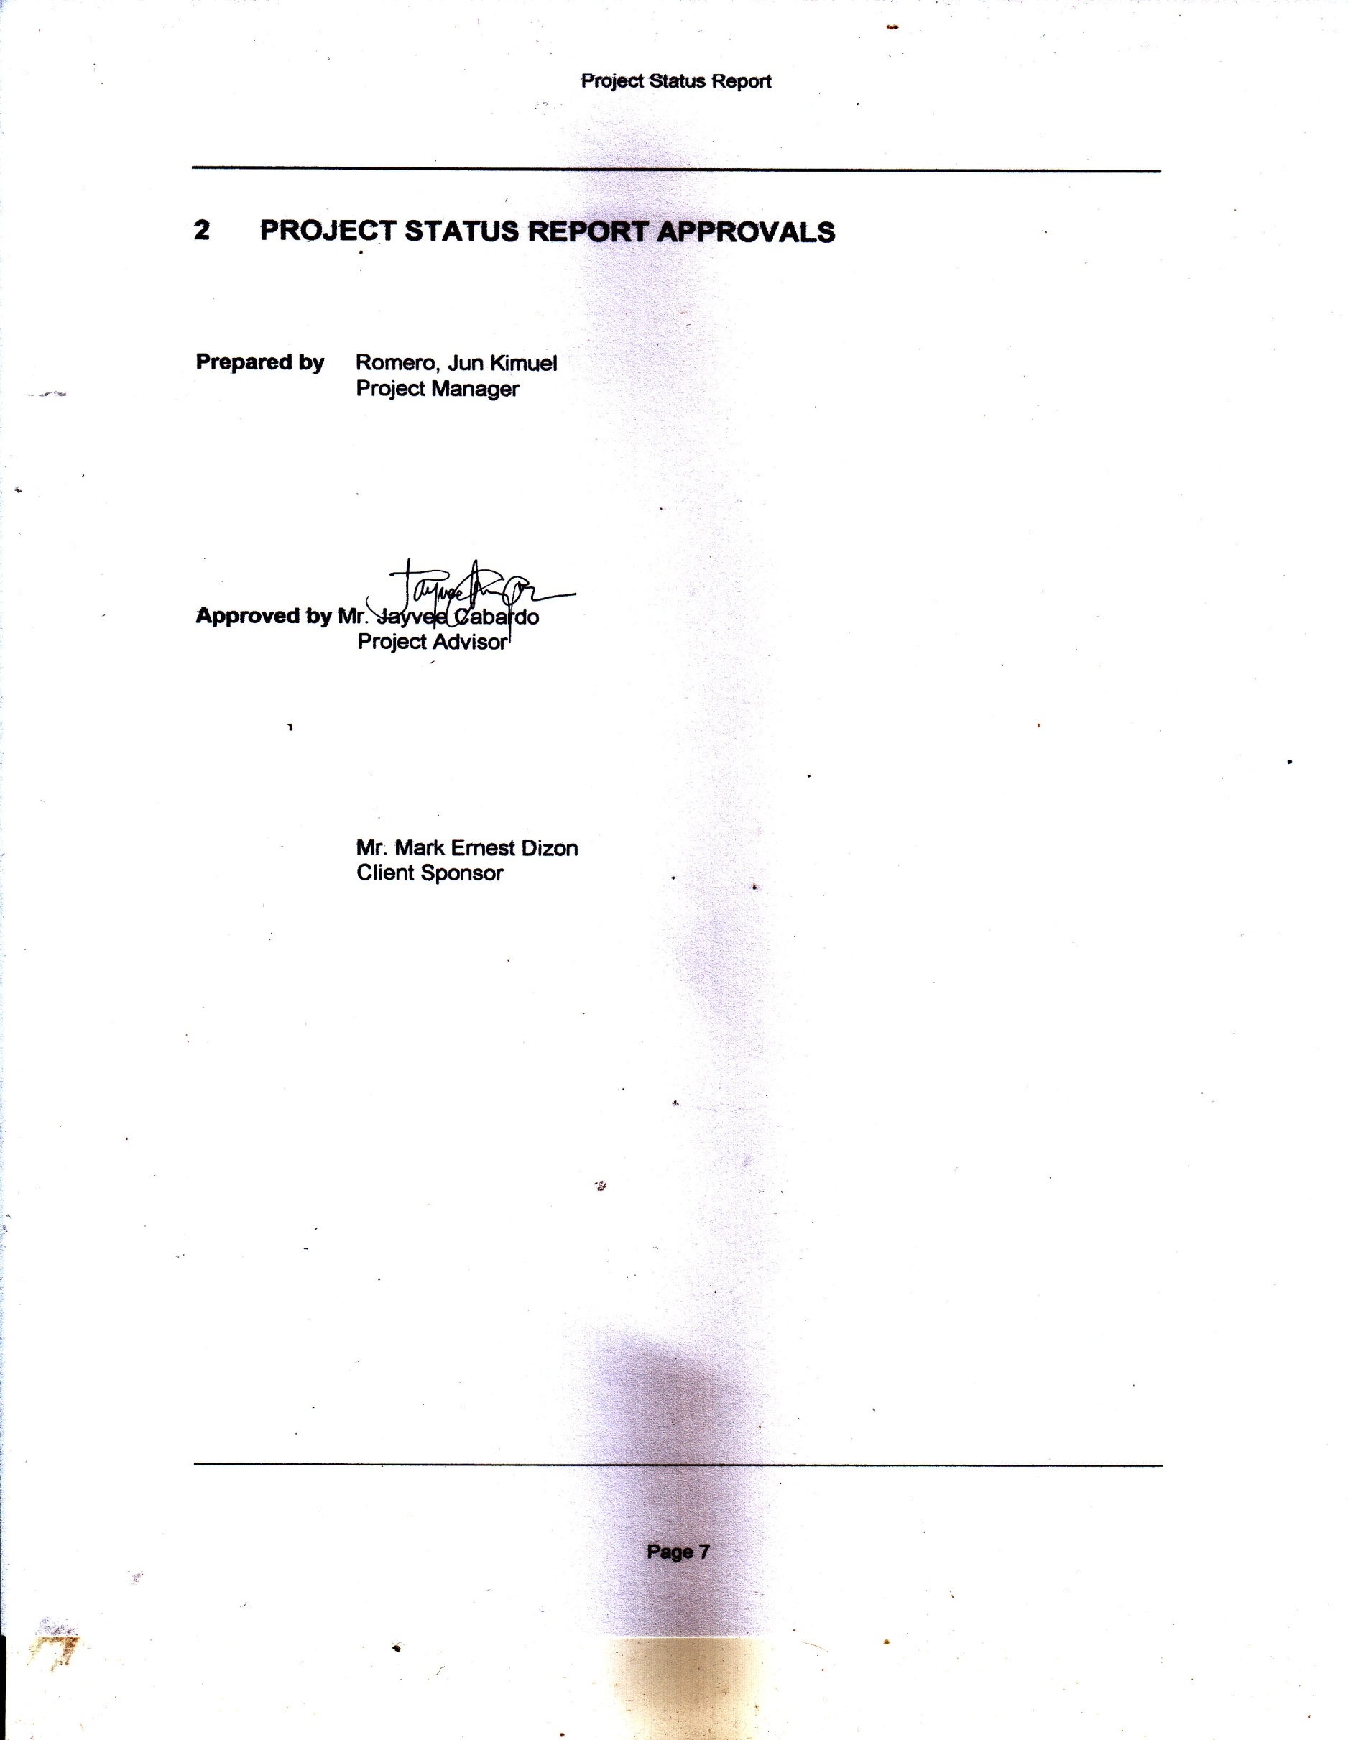

# PROJECT STATUS REPORT APPROVALS

**Prepared by** Romero, Jun Kimuel

Project Manager

**Approved by** Mr. Jayvee Cabardo

Project Advisor

Mr. Mark Ernest Dizon

Client Sponsor

# 

# APPENDICES

## Document Guidelines

## Project Status Report Sections Omitted